Collection and Aggregations screenshots:

Movies which matches 10 rating

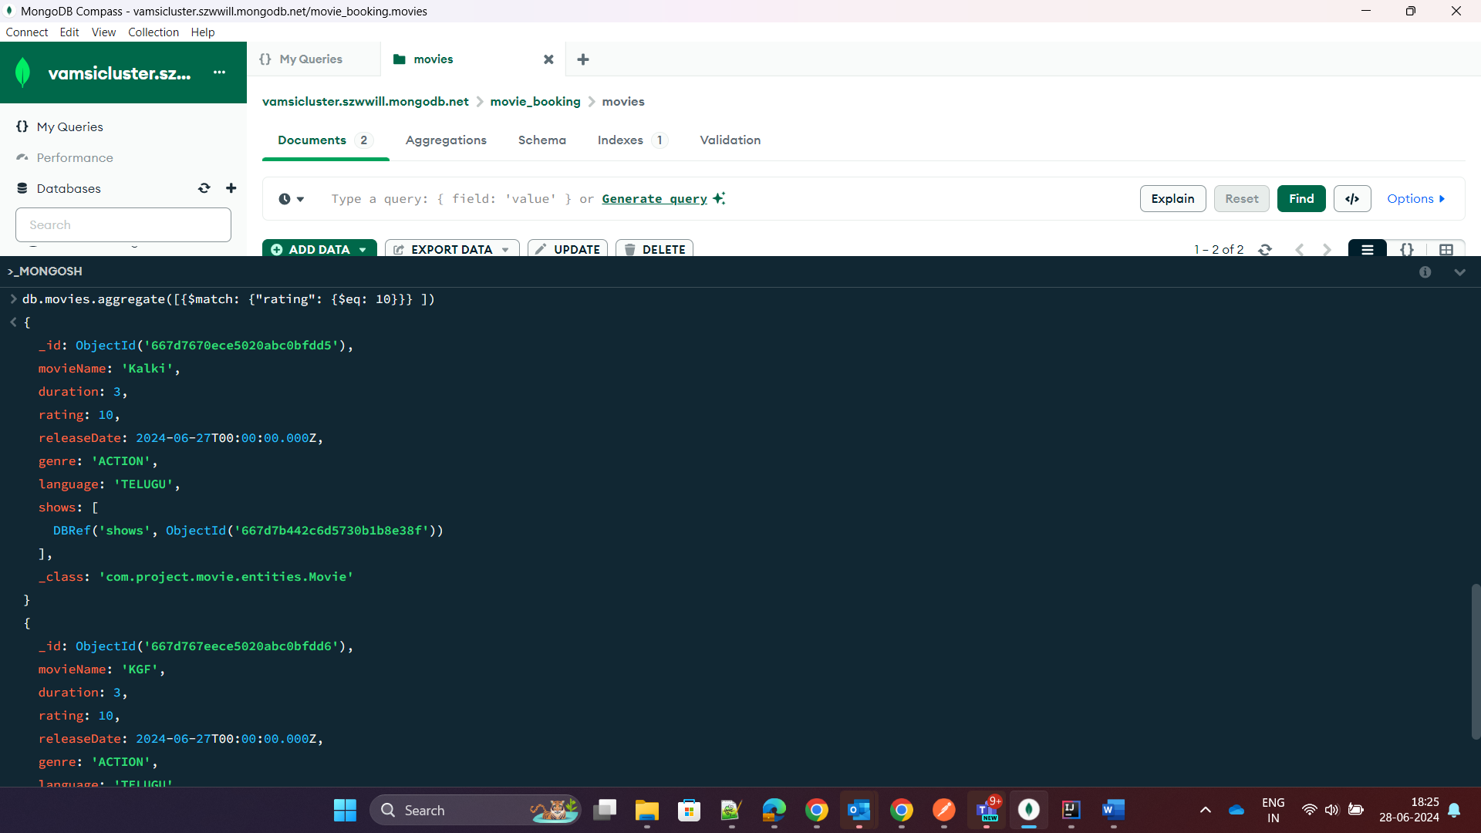

Total No of count on how many movies have 10 ratings

db.movies.aggregate([{$match: {"rating": {$eq: 10}}},

{

$group: {

_id: '$movies.movieName', totalmovies: {$sum:1}}

}

])

Duration which matches 3 hours duration

Collections:

Movies:

{

"_id": {

"$oid": "667d7670ece5020abc0bfdd5"

},

"movieName": "Kalki",

"duration": 3,

"rating": 10,

"releaseDate": {

"$date": "2024-06-27T00:00:00.000Z"

},

"genre": "ACTION",

"language": "TELUGU",

"shows": [

{

"$ref": "shows",

"$id": {

"$oid": "667d7b442c6d5730b1b8e38f"

}

}

],

"_class": "com.project.movie.entities.Movie"

}

Show seats:

Shows:

Theater seats:

Theaters:

Tickets:

Users:

